Day 39 – Data Storytelling

Data Storytelling :

- Data storytelling is the broader skill of communicating insights in a way that resonates with your audience.
- This technique brings together data analysis, visualization, domain knowledge, and thoughtful presentation to make insights clear, compelling, and actionable. Instead of just sharing data, you deliver a data story with clarity, context, and purpose, so your message resonates.
- So its basically , Using data + visuals + context to communicate insights clearly and drive decisions.
- A good story answers : What is the problem? What does the data show? Why does it matter? What should be done next?

Why is telling a story with data important?

1. Makes data understandable
Not everyone speaks the language of data. Data storytelling helps you translate complex analysis into something everyone can relate to. With the right visuals and context, insights stop being ‘just numbers’ and start becoming ideas your team can act on.

2. Builds trust
When everyone’s working from the same clear story, it creates alignment. Your team isn’t just handed charts or dashboards; they’re brought into the full picture. That shared understanding builds trust in both the data and the decisions that follow.

3. Drives better decisions
Raw data rarely inspires action on its own. But a well-told story? That’s a catalyst. By connecting insights to business context, storytelling turns analysis into action, helping your team see what’s happening, why it matters, and what to do next.

4. Supports collaboration
A compelling data story invites conversation. It gives your team a shared frame of reference, making discussions more focused, productive, and strategic. Instead of debating opinions, you’re creating solutions grounded in evidence.
Structuring insights

Step 1 – Define the Business Problem
Start with the real-world problem.

Bad Business Problem
“We analyzed customer data.”
Too vague.

Good Business Problem
“The company was facing high customer churn, causing revenue loss.”
Now it gives some information..

Step 2 – Give Context
Explain:
- who is affected
- what metric matters
- why this problem matters
Example:
- Telecom company
- 26% customer churn
- Losing recurring subscription revenue

Step 3 – Show Key Insights
This is where visualization comes. We should not show every analysis of what we did. We need to show insights that really help decisions.
Example:
- Customers with month-to-month contracts churn more
- High support ticket users churn more
- Fiber internet users complain more

Step 4 – Explain Impact
Explaining the impact after key insights is important as here we will narrate about the insights we got from the model.
We should not stop at saying “Feature X is correlated with churn.” Instead we need to Say “Reducing complaints among fiber users could reduce churn risk significantly.”
Now it becomes business-focused and has a well defined impact.

Step 5 – Recommend Actions
Example:
- Offer annual plans
- Improve fiber service quality
- Trigger retention offers for risky customers
Without recommendations, our analysis is incomplete.

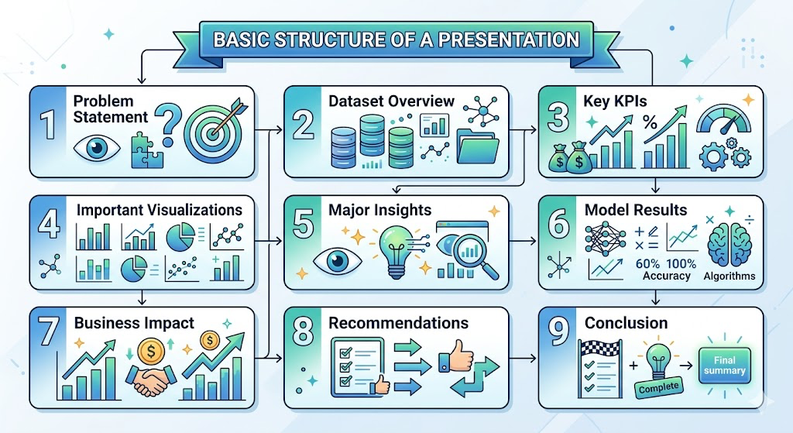

Visualization best practices :

Understanding Your Audience and Purpose
Before jumping into design principles and chart options, it’s important to step back and think about the “why” behind your visualization. Understanding your audience and the purpose of your visualization is fundamental to best practices of data visualization. These two factors will guide your decisions.

Who’s Your Audience?
Creating visuals for expert statisticians is a whole different ballgame compared to designing a chart for a general audience. Keep these key factors in mind:
Existing knowledge: How familiar are they with the topic and interpreting data visuals?
Technical expertise: Will they grasp complex statistical concepts, or do they need simpler, more straightforward presentations?
Interests and expectations: What are they most interested in, and what kind of visual style will connect with them?

What’s Your Goal?
Think about what you’re trying to achieve with your visualization. Are you:
Exploring data: Digging into a dataset to spot trends or outliers for your own analysis?
Communicating insights: Presenting your findings to stakeholders in a way that’s clear and convincing?
Telling a story: Using data to craft a narrative that sparks emotions or drives action?
The purpose of your visualization will guide your choices, from the type of chart you select to the level of detail you include.

Choosing the Right Chart Type
Think of chart types as your storytelling tools. Each has its strengths and works best for specific data and narratives. Let’s look at some data visualization examples:
Bar Charts: Great for comparing categories or showing changes over time.
Example: Comparing quarterly sales performance across different products.
Line Graphs: Perfect for visualizing trends and patterns over time or continuous data.
Example: Tracking a company’s stock price over a year.
Pie Charts: Best for illustrating proportions of a whole but should be used sparingly with limited categories.
Example: Showing the market share of different operating systems.
Scatter Plots: Ideal for showing relationships between two variables and spotting correlations.
Example: Analyzing the link between advertising spend and sales revenue.
Maps: Excellent for visualizing geographical data and regional variations.
Example: Displaying population density across U.S. states.
Choosing the right chart type depends on a few factors:
The nature of your data: Is it categorical, numerical, time-series, or geographical?
The relationship you want to highlight: Are you comparing values, showing trends, illustrating proportions, or exploring correlations?
The complexity of your data: How many variables do you need to display, and how detailed should it be?
By keeping these factors in mind, you can select the chart type that best fits your data and delivers your message effectively. The goal is to make your data clear, concise, and engaging so your audience can quickly grasp the key insights.

Best Practices in Data Visualization
Once you’ve chosen the right chart type, it’s time to dive into the details that take a good visualization and make it great. This is where best practices in data visualization truly come into play.

Clarity and Simplicity
In data visualization, less is more. A cluttered chart can overwhelm your audience and obscure key insights. Focus on clarity by:
Using clear labels: Keep axes, data points, and legends concise and easy to read with appropriate fonts and sizes.
Removing unnecessary elements: Skip excessive gridlines, borders, or decorative features that distract from your message.
Embracing white space: Use white space strategically to separate elements, guide the viewer’s eye, and create visual breathing room.

Accuracy and Honesty
Data visualization comes with the responsibility to present information truthfully and avoid misleading your audience. Manipulating scales, cherry-picking data, or using deceptive visuals can distort the truth and undermine trust.
Here are a few considerations:
Use accurate scales: Keep scales consistent and ensure they reflect the data’s true magnitude. Avoid exaggerating or downplaying trends.
Provide context: Include relevant timeframes, units, and other details to help your audience fully understand the data.
Avoid bias: Watch for biases in your data or presentation and aim for transparency and objectivity.

Visual Hierarchy and Emphasis
Help your audience focus on the most important information by creating a clear visual hierarchy. Use visual cues to highlight main data points, trends, or comparisons.
Here’s how to do it:
Use color strategically: Highlight important data points, distinguish categories, or create associations with color. Keep the palette simple to avoid overwhelming the viewer.
Vary sizes: Make key data points or elements larger to naturally draw attention to their importance or magnitude.
Optimize placement: Position critical information prominently, following the natural reading flow (left to right, top to bottom) to guide the viewer’s eye.

Accessibility Matters
Great data visualizations should be accessible to everyone, including those with visual impairments. By implementing accessibility best practices, you can ensure your message reaches a wider audience.
Choose accessible colors: Use colorblind-friendly palettes and ensure enough contrast between elements.
Include alternative text: Add alt text for charts so screen readers can describe the information to visually impaired users.
Use clear fonts: Use readable fonts and appropriate sizes to make your visuals accessible for people with low vision.

